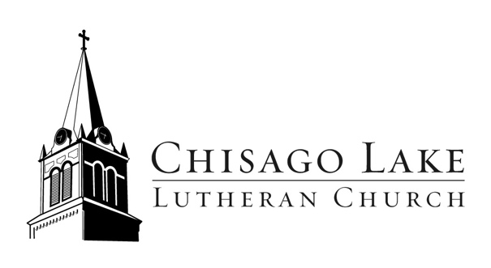
1 Summit Ave
PO Box 175
Center City, MN 55012

(651) 257-6300
www.chisagolakelutheran.org

August 3, 2020

Dear CLLC,

With recommendation from the Resurrection Team and the support of Council, we have decided to hold our first outdoor worship service on Sunday, August 9th at 9:00am on the upper lawn at Chisago Lake Lutheran.

Based on what we know about how COVID-19 spreads, we do not believe it is safe to return to worship indoors. We are trying outdoor worship because the risk of transmitting the virus is far less with proper social distancing.

We have put into place several guidelines to keep you and your neighbor safe during outdoor worship. They are:

- You will need to bring your own lawn chair or blanket. All individuals/families will be seated in a ‘pod’ on the lawn (circles spray painted, each 6 feet apart). This will help provide some parameters for how we physically gather.
- Though we are outdoors, we may be a large group. Therefore, masks will be required of everyone over the age of 2.
- Attendees will need to register ahead of time by signing up on the church website (www.chisagolakelutheran.org) or calling the church office at (651) 257-6300. We will cap registrations at 100 people.
- Upon arrival, each family will need to fill out a simple health form. This will help us with contact tracing should we need to use it.
- All services are weather permitting. In the case of inclement weather, we will make the call at 7:30am that morning whether to cancel. An announcement will be posted on the website, emailed, and posted on the church door.
- The service will be live-streamed and aired later that night on Channel 10. If canceled due to weather, an abbreviated service will be posted online.
- The service will be approximately 30 minutes. There will not be communion or corporate singing encouraged. (Please remember that Pastor Taryn is offering Communion & Prayer every other Wednesday outside the upstairs church door from 6-7pm. This Wed, Aug 5th is the next one).
- The restrooms will be available. An attendant will let you into the building.
- There will not be any organized fellowship time before or after the service.
If you are 65 years or older or at high risk for infection, we ask that you thoughtfully consider whether attending is in your best interest. We have an aging congregation, and we take your care and well-being seriously.

Holding outdoor worship under these circumstances will take additional volunteer help – registration table, ushers, set-up and take-down, etc. If you are able, please contact Pastor Taryn.

The Resurrection Team continues to meet and make plans for our eventual return to indoor worship. Earlier this summer we set a goal of September 13th for this. As cases continue to rise and the rate of infection spreads, we are mindful of how this might affect our ability to do so. And likewise, our Sunday School, Confirmation, and Wednesday night activities. While we intend to keep moving forward, we also know that doing so faithfully and with deep care for one another, might mean rolling those plans back. We appreciate your understanding and patience.

Our policy remains that the sanctuary is available for small gatherings of 10 people or less (baptisms, funerals, weddings, etc.), or for slightly larger numbers with approval. Following the Stay Safe Minnesota plan, staff continue to work remotely. They are available for safe socially distanced meetups as needed, or by phone and email. As always, if you have a pastoral concern or emergency please contact Pastor Taryn at (651) 508-0277.

As a church, we continue to be strong, vibrant, and faith-filled people of God through this experience. We trust that God is guiding us and that our ministry is growing and evolving through it all. We are grateful for your support, feedback, and accompaniment as we walk this journey together.

If you have questions or concerns, please do not hesitate to reach out to one of us. Know that your feedback will be shared with the group as we make these important decisions.

Yours in Christ,
The Resurrection Team

Carrie Benson (propertycllc@gmail.com)
Tom Leaf (tleaf2@fairview.org)
Betsy Nordby (mbnordby@frontiernet.net)
Lee Peterson (peterson.lee@gmail.com)
Sara Peterson (Sara@pmanor.com)
Kristi Warner (Kristi.warner@abbott.com)
Louise Angrimson (office@chisagolakelutheran.org or 651.257.6300)
Pastor Taryn (pastortaryn@chisagolakelutheran.org or 651.508.0277)

